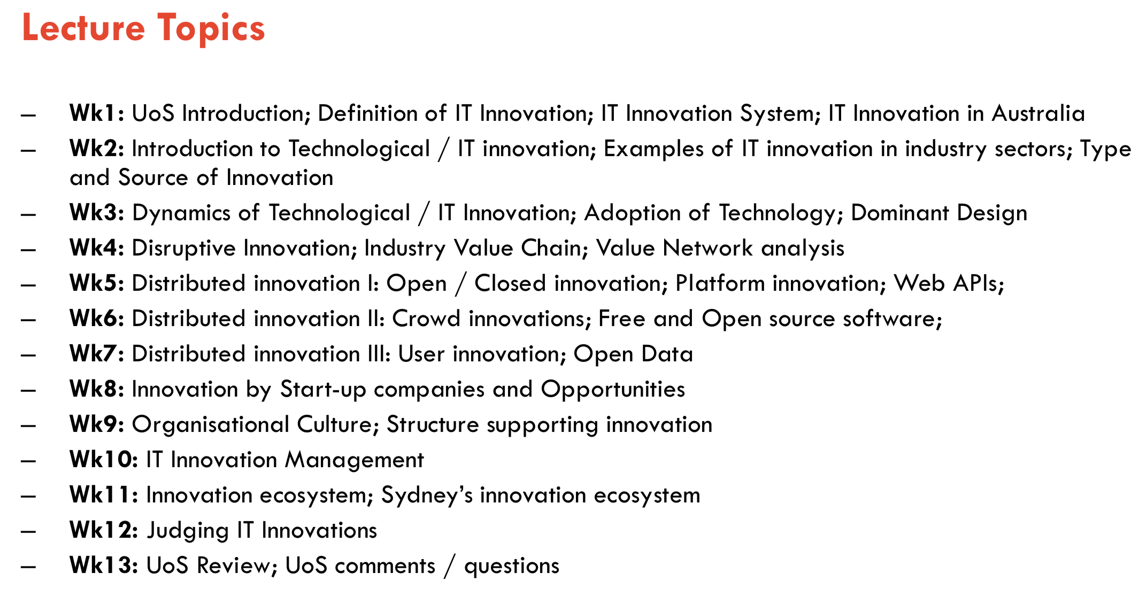

**Week1**

**Lecture:**

Level of Innovation: Society, Organization, Individual or team

Relevance to IT careers (benefit from):

1. Enterprise: analyze likely impact from new technologies for their adoption
2. R&D: lead the development of new technologies within and established organization
3. Start-up: create software start-up

**Definition**:

Invention: It is the first occurrence of an idea for any product or process.

Innovation: According to Schumpeter, is a new idea applied commercially. Thus innovation is more than just coming up with a new idea, it involves combining a creative idea with resources for building new products, services, processes or business models.

**Importance of innovation:**

1. The importance to a country:

Innovation is a driver of productivity, growth, Improvement in living condition.

1. Is often the most important competitive driver in many industries
2. Leads to improvements in productivity
3. Is strongly linked with improvements in GDP
4. Is linked to improvements in standard of living including:

Job creation

Improved enjoyment of life

Health improvements

Education improvements

Addressing national or global issues

1. High growth firms use innovation
2. To a company:

innovative companies have greater productivity, revenue, growth, social contribution.

**Importance of IT innovation:**

1. IT as “general purpose technology”(GPT)
2. IT as enabler of innovation in other fields

IT as a horizontal has helped innovation in all the vertical field such as health, transport, education.

1. IT innovation as Creative Destruction
2. Improvement in IT can change whole industries.

Music Industry, advertising industry

1. “Software is eating the world”

It means more and more major businesses or industries are run on software, and delivered as online services. In addition, technology required to transform industries through software finally works and can be delivered globally

**Innovation cycle**

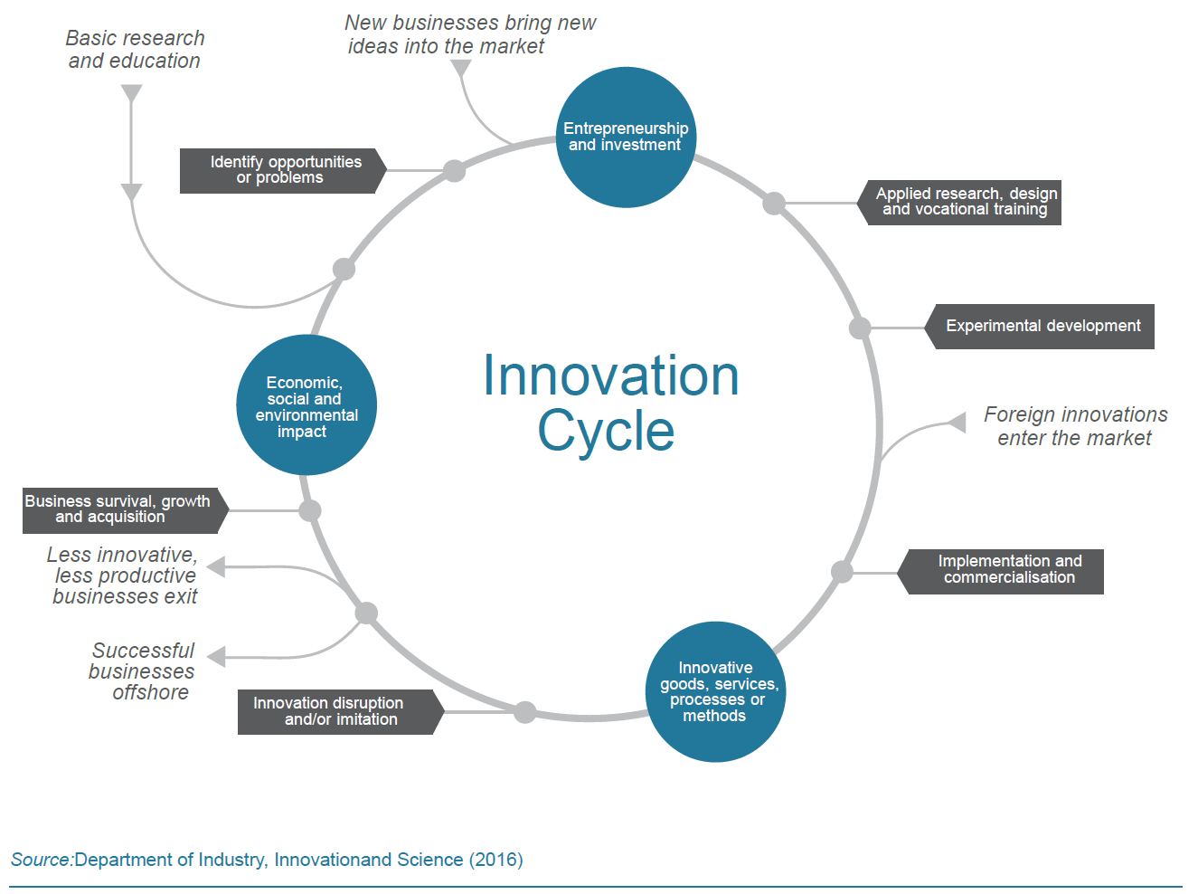

**Tutorial: Importance of Innovation to a Country-Government’s role in Innovation**

**Q1: what are some of the ways that the Government can support innovation?**

**Financial:**

1. Direct grants to support R&D or commercial projects (different kinds of grants 拨款)
2. Subsidies: 津贴

-Government provides support for R&D, low interest rate funds/loan, strong push towards releasing data (eg: Healthcare) .

-Government provide tax incentives, subsidies, and other investment options for support.

-Early-stage venture capital and tax incentives for R&D to private or community sectors that do not have sufficient economic incentives.

1. Investment:

-Investments on infrastructure, health, education and research.

-Invest in research education and make the infrastructure affordable to take the cost burden out of invention

-Investment in high-risk, high-reward research

-Generate maximum impact through collaboration and co-investment by ensuring public sector investments.

**Law, policy and cultural**

1. Bring skillful workers/immigrants from other countries to promote our innovation.
2. Governments can make innovation friendly policy schemes
3. Intellectual property protection
4. Corporate and labor law
5. Providesshort-termlimitedsupportandadviceservicesforcommercialisation to overcome market or system failures.
6. Building talent and skills through education schemes

**Q2: Why do you think these examples were publicly funded and not privately funded**

**Financial:**

-Requires huge amount of resources (capital, knowledge, labor and time) for investment that the private fund could not invest easily.

-Government investment requires contributions from various areas, not just from single company or industry.

**National interests:**

-Some of the technologies should be kept within the government, e.g. military, energy

-Different value proposition: private companies are more driven by revenue, which is not always the case for governments.

**Week2:**

**-IT is a “general purpose technology” (GPT)**

A GPT has the potential to affect the entire economic system and can lead to far-reaching changes.

-Like electricity: It enables other technologies

-GPTs differ from other technologies:

GPTs are pervasive

continually improve in usefulness and lower in cost

spread innovation in other areas, making it easier to invent and produce new product

**Creative destruction**

waves that restructure entire industries and markets in favors of those who grasp and adapt to technological changes faster!

Example:

Amazon :Largest bookseller in world is a software company

Spotify, Apple: Dominant music companies are software companies

**Type of Innovation**(Different dimensions for understanding types of innovation)

1. What type of thing is being innovated?

Product innovation(iphone), process innovation(3D print), business model innovation (Uber)

1. How different is it from what’s already available?

Radical innovation(3D print) VS incremental innovation(a new version of software)

1. What impact will it have on the consumer?

Life-changing vs incidental(minor 次要的) innovation

1. What impact will it have on the market or industry?

Disruptive vs sustaining

1. What scope of the produce does it affect?

**Architectural vs component innovation**

Architectural innovation needs changing the overall design of the system or the way components interact.

– e.g. cloud computing

– e.g. sharing economy platforms

Component innovation involves changes to one or more components of a product system without significantly affecting the overall design.

– e.g. smartphone generations...

1. What impact will the innovation have on the producers?

Competence-enhancing vs competence-destroying innovation

**Tutorial: IT innovation in the Education sector**

1. Identify the key enabling IT (software, hardware, etc) used in MOOCS:

Internet, big data, web-browser, PC, WiFi, smartphone, webcam, finger / retina scanner (for identification), clouds computing.

1. Discuss the evolution of the education industry due to the introduction of moocs.

**Student** – location independent (No Longer restricted to a classroom), wide variety of courses available (Not have to strictly follow a curriculum), personalized learning--upskill themselves based on professional requirements, no age restriction, reduced cost for students

**Teachers** – flexibility (time, location), software can do some work (grading), better collaboration between students and teachers, MOOCS helps in developing basic technology literacy (navigating the internet, using a computer of a software etc.)

**Institutions** – MOOCS is widely recognized and therefore it’s important to be a part of it. e.g., all major Universities support MOOCS

**Invintors** – cost savings (teachers and infrastructure – No need of building massive infrastructure), direct assessments on students’ skills based on their course performance

**Week3**

**Diffusion of innovation**

Definition:

Diffusion is the process in which an innovation is communicated through certain channels over time among the members of a social system

**Technology Adoption Lifecycle Model**

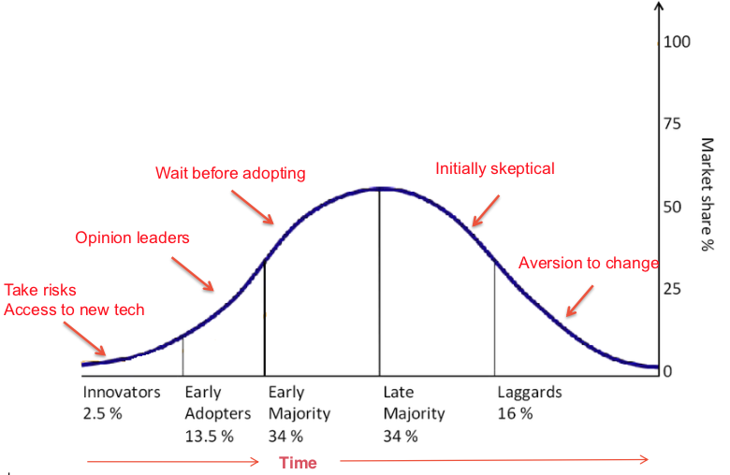

1. Take risks access to new tech
2. Opinion leaders
3. Wait before adopting
4. Initially skeptical
5. Aversion(厌恶) to change

“The Chasm”(鸿沟)

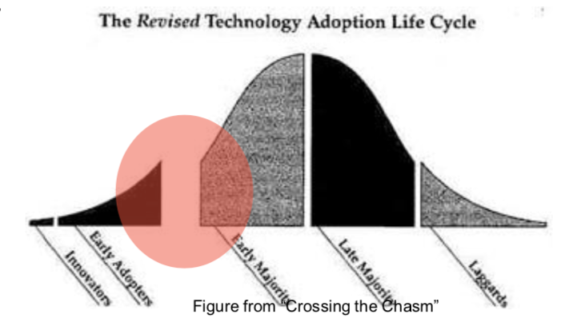

1.companies are hard to get from early adoption to mainstream

2.if the chasm can be crossed, then there’s an opportunity for dominance

“S-curve”( the same information with above)

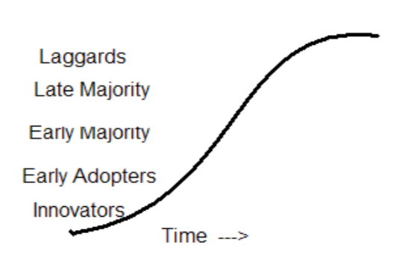

Process of innovation adoption:(adoption by Individuals or Organization)

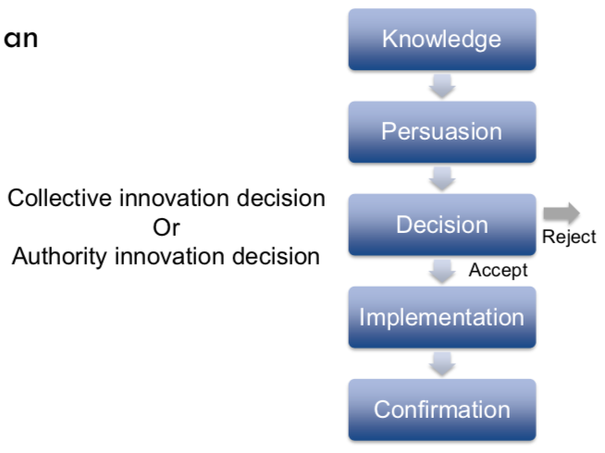

The factor of rate of adoption

Relative advantage

Compatibility

Simplicity

Trial-ability-degree

Observe-ability-extent

Rate of technology adoption:

Technology get to 50% penetration more quickly but often don’t reach saturation due to other technologies replacing them

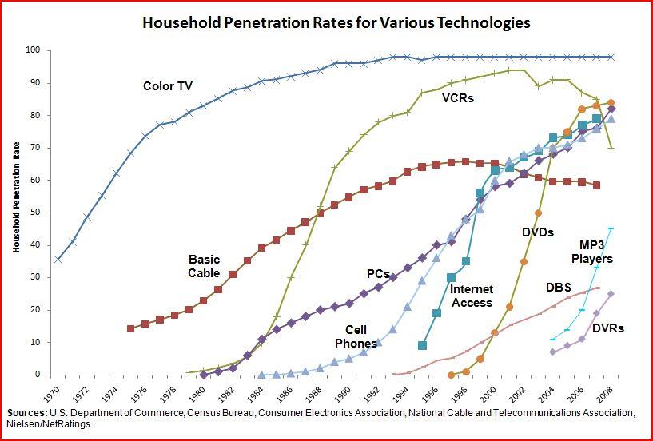

**Overall reasons for lack of adoption:**

1.Disrupted by other innovations(VCRs)

2.Not suitable for majority of people

3.The supporting technologies for innovation are not work well, resulting not well Customer experience.

**Product category:**

A product category is all products offering the same general functionality

**Dominant Design:**

Concept:(come from a study of automotive industry)

-A “dominant design” is the design around which the industry settles.

The process by which the dominant design happens

1. when a new product is first introduced
2. if the product attracts significant market share
3. competitive products are released
4. The dominant design may be established by the first company to release a product.
5. The dominant design becomes a base for the whole industry.

Phase of DD:(two phases)

-The fluid phase:

1. Uncertainty about the technology and its market
2. Firms experiment with different product designs

-The specific phase:

1. There’s a stable architecture for the technology
2. Firms focus on incremental innovations to improve components
3. Firms focus on process innovations to produce them efficiently and effectively

Design Dominance and Technology Cycles

-The dominant design was never in the same form as the original innovation

-The dominant design was not the leading edge of the technology

-The dominant design had the features that met the needs of the majority of the market

-Example: The IBM PC (and clones) were not the most advanced or the cheapest technology at the time it rose to dominance.

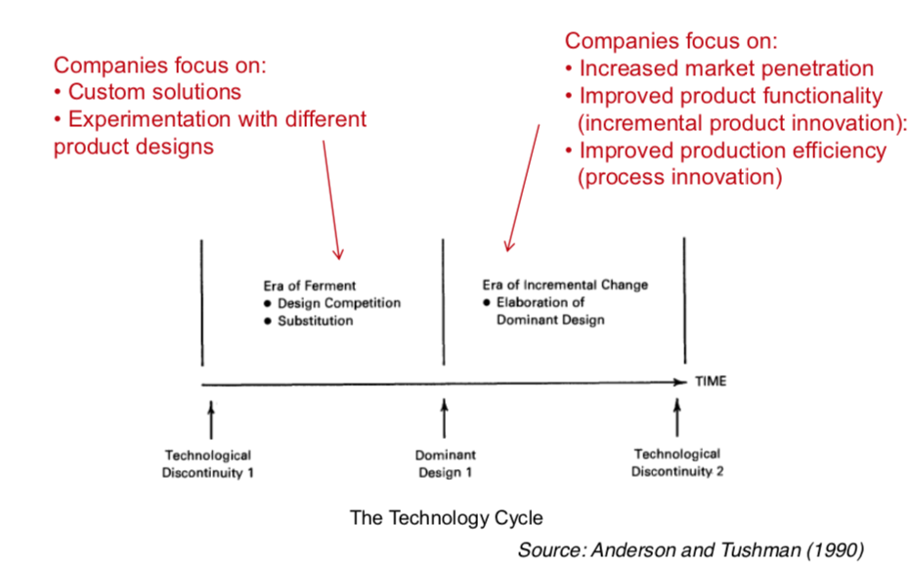

**Why dominant design gets selected in market(2Point)**

1. Market forces: Increasing returns to adoption, the more technology is adopted, the more valuable it becomes.

(1) Learning effects: The industry gains knowledge in all aspects of the technology

-dominant design leads to greater use of the technology

-greater use leads to greater knowledge

-greater knowledge enables a fast rate of improvement

(2) Network effects:

-for technologies with network effects, the benefit from using a technology increases with the number of other users (ex: telephone, Facebook)

four types of network effects:

-direct: increase in usage leads to direct increase in value (telephone)

-indirect: increase in usage leads to increase in value of complementary goods (PC architecture)

-two-sided network effects: increase in usage by one set of users increases value to another set (eBay)

-local network effects: increase in use of local networks leads to increase in value (wechat)

The self-reinforcing cycle:

-Large installed base attracts developers of complementary products

-a technology with wide range of complementary product attracts more users

-increase in users is an increased installed base

1. Government regulations:

Governments sees the importance of a technology for a nation and regulates a specific dominant design (TV, 5G, satellite)

Rather than wait for market forces, sometimes government organizations step in and impose a standard

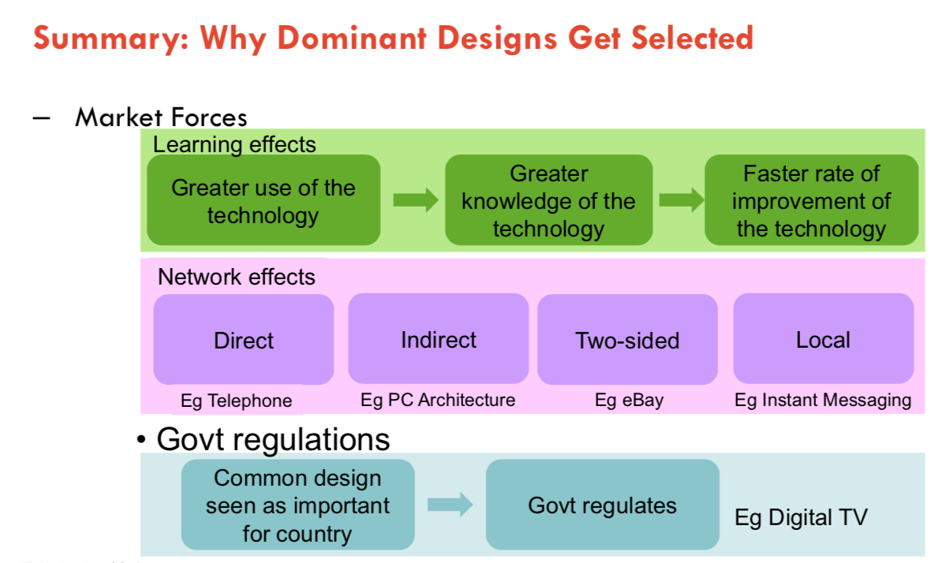

First, Second, and Fast Second

-First mover

getting into market quickly and hoping that your product becomes the dominant design (Bluetooth USDY)

-Second mover

waiting for the dominant design to be completely established and accepted in the market and then producing ‘me-too’ product under that standard (5G protocol)

-Fast second

waiting for the dominant design to begin to emerge and the moving to be part of it that is, helping to create it

**Tutorial: Dominant Design in the smartphone Market**

1. What are the main reasons that led to Android become the dominant design in the market?
2. An open source platform
3. Diversified vendors and product
4. Fast enough
5. Be dominant in market
6. Wide range of price
7. Google own week control on app publication
8. Android’s strategy for the VR is following similar principles to what made Android the dominant design for the smartphone OS. Do you think this strategy will become the dominant design in the VR space?
9. Mobile(handy) for VR devices
10. Diversified vendor and products
11. Compatibility
12. Cheap
13. Simplicity: as there’s no need to setup anything
14. Many sponsorship (like BBC)
15. Do you think Apple’s AR can become the dominant design of ‘Reality’ technology for smartphones?  yes
16. Huge customer base
17. AR technology is mature
18. AR well fits to mobile
19. Doesn’t require separate AR sensors
20. Cause software-based innovation to happen much faster
21. Do you need to be a smartphone OS to dominate in VR?

NO:

The top three market leaders in VR don’t own any OS, however, they own major App ecosystem.

**Week4**

**Disruptive innovation**

Technology performance over time

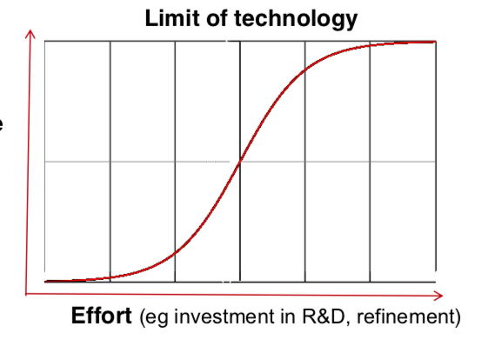

“Hype Cycle” model of the maturity and adoption of new technologies

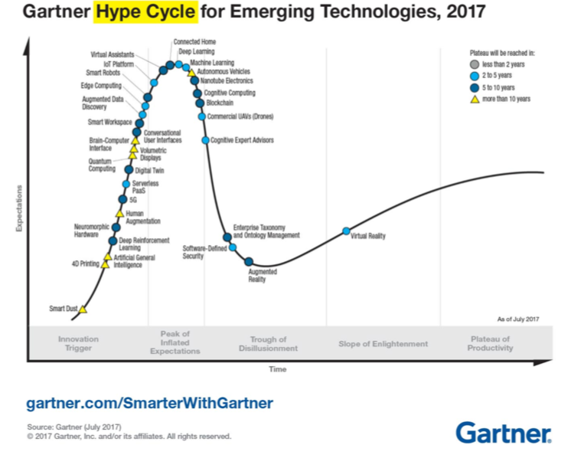

**disruptive innovation:**

they create new markets or change the **value network** in an existing market

--value chain focus on the whole system, while value network is for specific product

**Value chain:**

An value chain is a set of activities that a firm operate in a specific industry in order to deliver a valuable [product](https://en.wikipedia.org/wiki/Product_(business)) or [service](https://en.wikipedia.org/wiki/Service_(economics)) for the [market](https://en.wikipedia.org/wiki/Market_(economics)).

(product pass through stages and value is added at each stage)

**Analyzing value chains is useful for:**  
Understanding an industry (including relationships between companies)

Understanding your company’s position within the market  
Deciding where your company wants to be within that market  
Looking for opportunities for disruptive innovations

Types of disruptive innovation

1. “low-end disruption” – there are customers who do not need the full functionality or performance of products already on the market so cheaper alternatives can take over.

(ex: Wikipedia comparing traditional encyclopaedias)

1. “new-market disruption” – there are customers who have needs that were not being addressed by existing products

**Tutorial: Cognitive Services and its Value Chain**

1. Can you describe the underlying technology , and how it is used to provide the above cognitive services?

Web interface, GPU, Cloud computing, Machine learning, Digital image processing, Natural language processing

1. Can you think of a new business model using the cognitive service (technology)? Does it have the attributes to be a disruptive innovation? Answer this in terms of

does it gain a foothold in a low-end market that has been ignored.

does it create an entirely new market, turning non-customers into customers.

does it begin with low-quality offerings, then eventually capture the mainstream market by improving qualities.

**Week5**

Traditional model:

-Most R&D and other innovation done in-house

-Successful innovation required control

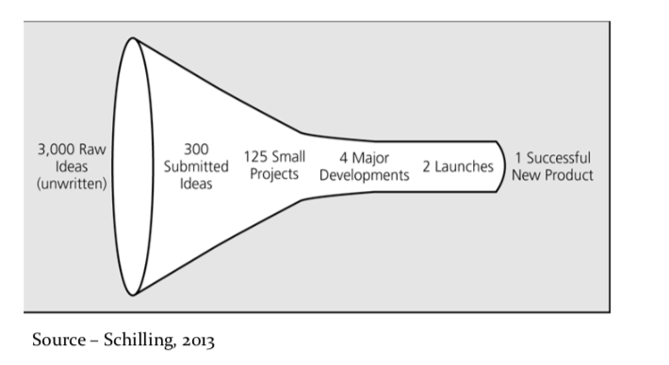

**Open innovation:**

Many companies have changed from purely internal R&D activities to being open to outside ideas and innovations.

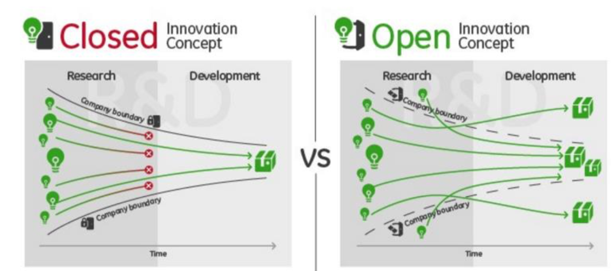

**definition:**

the use of purposive inflows and outflows of knowledge to accelerate internal innovation and expand the markets for external use of innovation

**Types** of open innovation (3)

1. Outside-in process:

– “Enriching the company’s own knowledge base through the integration of suppliers, customers, and external knowledge sourcing”

2. Inside-out process:

– “Earning profits by bringing ideas to market, selling IP, and multiplying technology by transferring ideas to the outside environment.”

3. Coupled process:

– “co-creation with (mainly) complementary partners through alliances, cooperation, and joint ventures.”

**Benefits** of Open innovation:

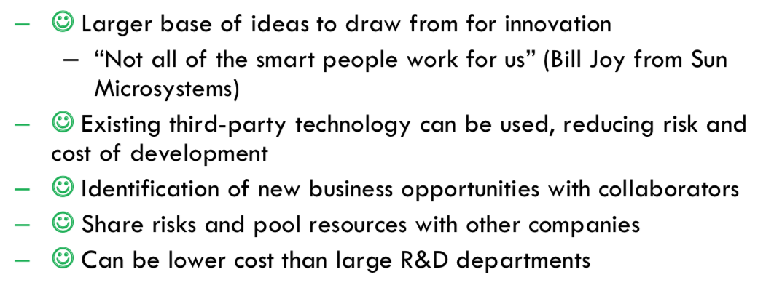

**Risks** of Open innovation:

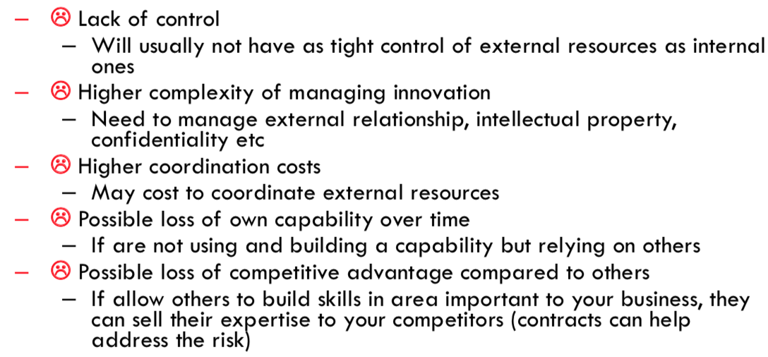

Balancing Open and Closed Innovation, Many companies do both and balance them

**Distributed Innovation:** Getting others involved in innovation

个人理解（distributed innovation属于open innovation）

Enabling distributed innovation: **Modularity**

A standard interface enables components to be combined easily

Product may be modular at User level, Producer level, Industry level

1. **Product Platforms**

Platforms make it possible for companies to:

– Have a rich line-up of different products with the same core functions(smartphone)

– To do so efficiently through re-use of a common platform

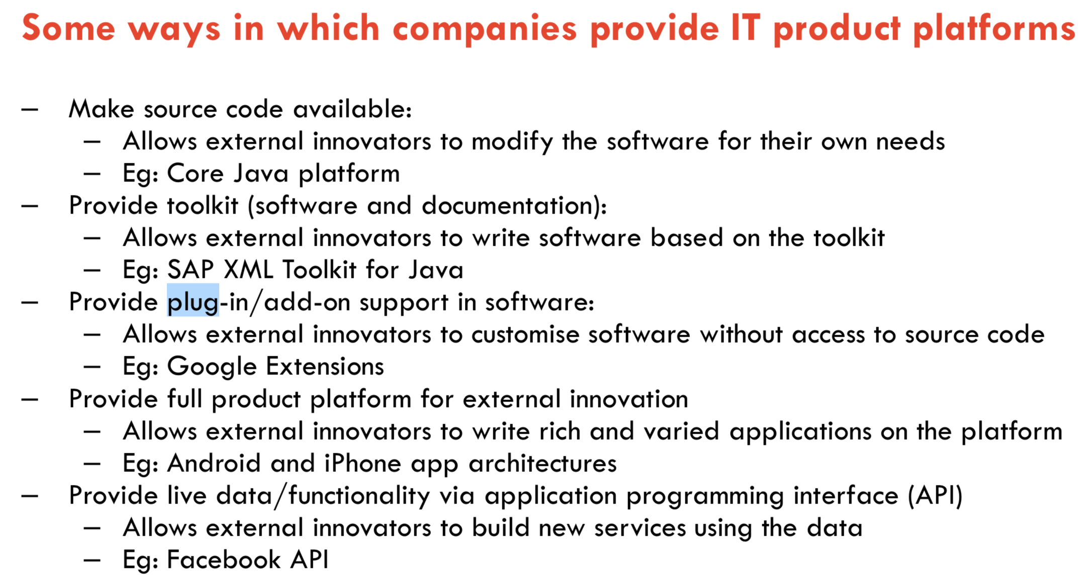

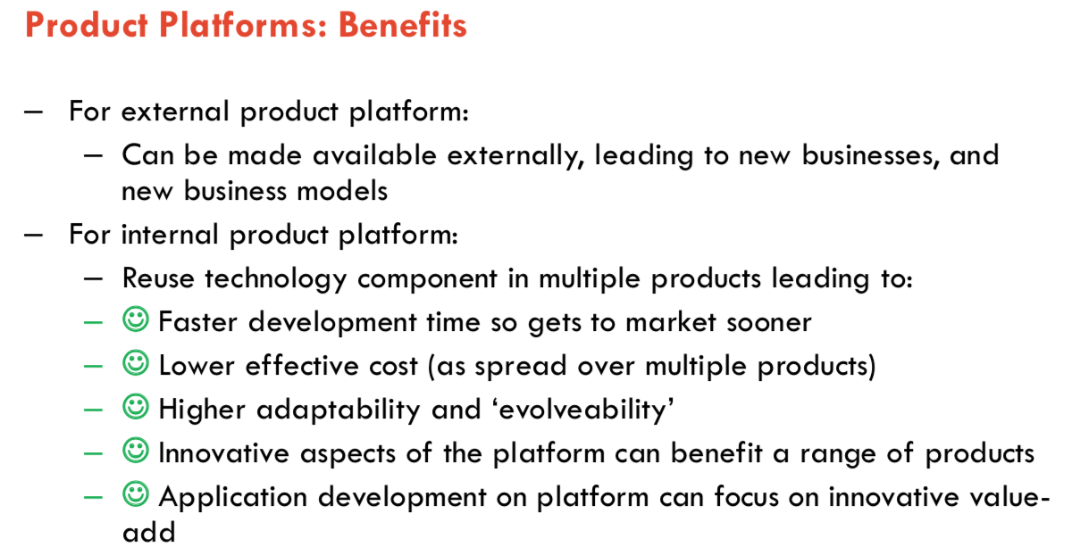

1. **Web APIs**

Interfaces for web-based services to interact (usually RESTful APIs)

**API Business models**

-API as a **product**: This category implies that the API has a specific money-making goal or serves as a significant or single source of income for the company.(Map)

-API **enhancing** existing product: A majority of APIs fall into this category. With the main money-making responsibility assigned to another part of the business (小工具)

- API **promoting** existing product: Designed to **solidify** the market position, APIs in this category are often offered for free, and work to attract interest and traffic to the API provider. (Alipay API )

Example:

Map, Payment, Messaging

1. **Crowdsourcing**

= Crowd + Outsourcing

Newer definition:

Crowdsourcing is a type of participative online activity in which an individual, an institution, a non-profit organization, or company proposes a problem, and the volunteer undertake the tasks.

**Types**

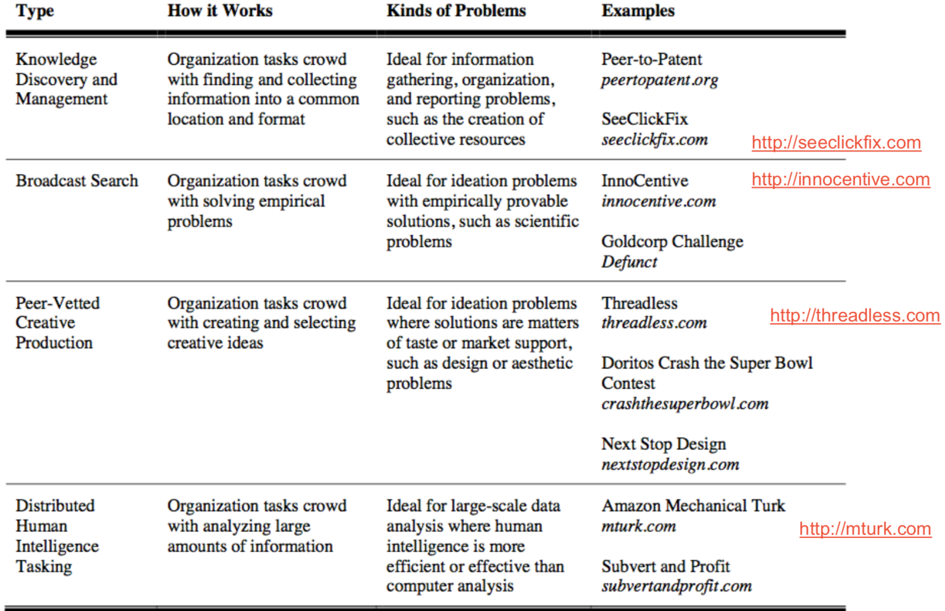

**topology**

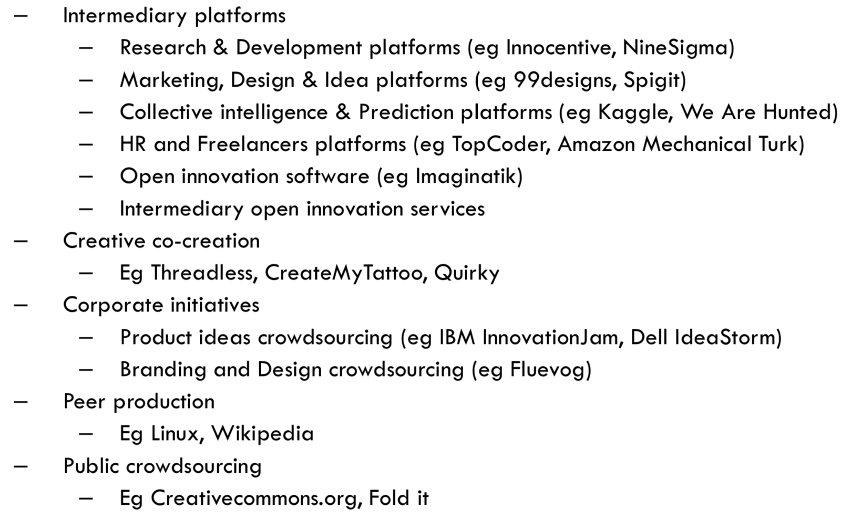

**Tutorial: Open Innovation**

The benefits of using open innovation

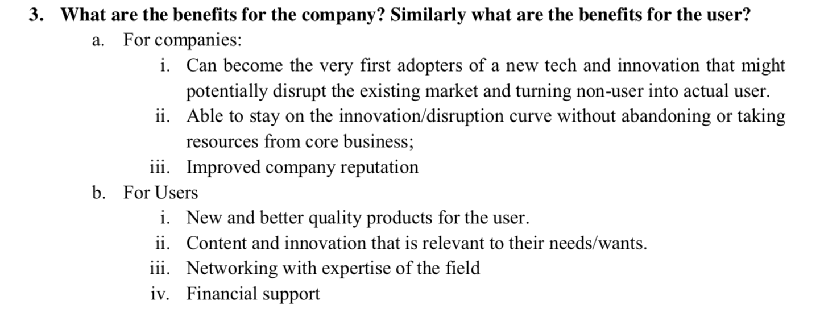

**Week6**

1. **Open data**

Open means anyone can freely access, use, modify, and share for any purpose

Many governments have opened up government data

**Value in open data**

Economic value: increased efficiency, new products and services

– Big data’s impact: replacing or supporting human decision making

– provide new business opportunities

– Governments to play a central role

1. **Free software/Open source software**

Free software is a matter of the users' freedom to run, copy, distribute, study, change and improve the software.

Why we need free/open source software

* If that software is controlled by companies or governments, the software can be used to restrict or monitor people

–  So, it is necessary that source code be available for all software

–  If source code were not freely available, a limited number of very powerful people would dominate computing

“Copyleft is a general method for making a program free, and requiring all modified and extended versions of the program to be free as well.”

(理解：copyleft allows an author to impose some restrictions,修改之后的也要free)

**Difference** **between Free Software and Open Source Software**

–According to Stallman, “Open source is a development method; free software is a social movement.”

–Open Source covers a wider range of license types.

–free software is ambiguous(混淆)

(理解)free很容易被混淆所以引入open source,后者更关注code,而不是rights

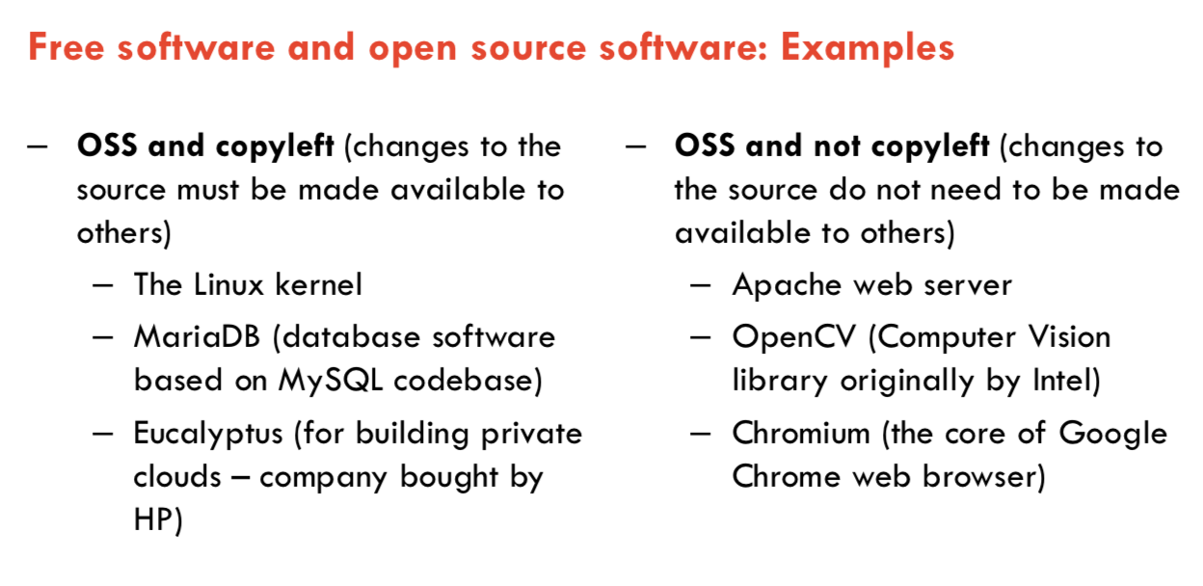

**Types of Business models and example**

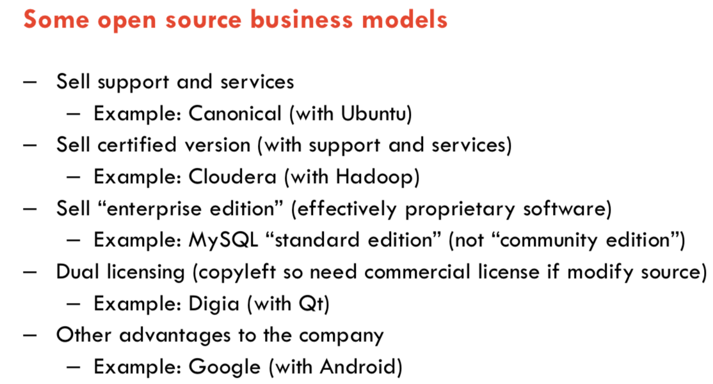

Licenses: permissive and restrictive

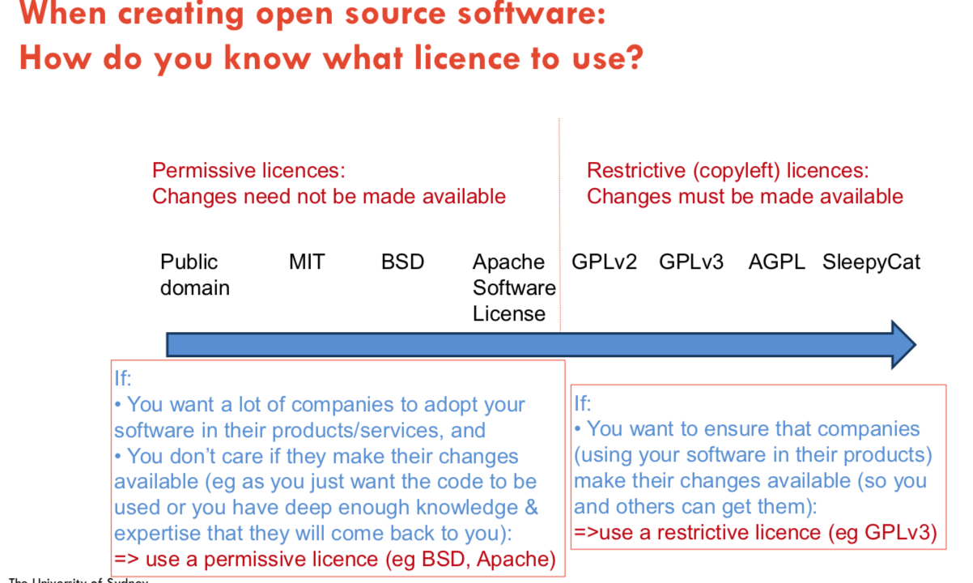

How can companies address the **challenges**

–  Companies developing products or services and using open source software should have an open source policy and controls to ensure good governance.

**Tutorial: Open Innovation with Maps**

**Question1:what are the distributed concepts employed by mapping API**

Product platform:

e.g. Google Map platform: integrated by services involves geolocations such as Pokemon go.

Web API :developers can use API to innovate their services  
Open source software: everyone can contribute  
User innovation: information from users can adapt to systems, which makes

the system more accurate and informative.  
Open data: Real-time traffic info from other platform

**Week7**

**F. User innovation**

**Traditional model of innovation : “Producer innovation”**

–  Producer makes product for consumers

–  Design for innovations come from producer companies

–  Producer innovators profit from many users of the same product/service

–  Assumption that a producer serving many customers can afford to invest more in innovation than a single user innovating for themselves

User innovation is the idea that users and consumers are the more of the innovators of new products than suppliers.

Example: WWW, Fire Fox add-ons, open source software is user innovation

**Lead users**

In some product categories, market research focuses on typical users

The feedback and opinions of typical users can be useful in developing new products.

Why engage with lead users?:

Lead users can provide concepts for products, services, processes to help companies innovate

an alternative perspective(negative)

--Users insights can’t predict future demand

--User-centered processes skill creativity

--User focus makes companies miss out on disruptive innovations:

--User-led design leads to sameness

**Apple’s view:**

Apple makes products that themselves want to use. They are their own leading-edge customers.

**Maker movement:**

The Maker Movement is the embodiment(化身) of the do-it-yourself, tech community — a celebration of the ever-growing culture bred from the cross section of collaboration and creativity that is continuously recruiting people and ideas and technologies and inviting them to be tested and broken and shared. Makers are everywhere — welding in a garage, tucked away in a lab or DIY- ing on the living room floor — but the community’s unofficial headquarters are all around the nation, and creating a place for makers of all kinds in the form of Makerspaces.

–  IT is a key enabler to rapid increase in IT innovations

–  But not only in IT.... there are many other ways for innovation to occur

–  Maker movement has made tremendous interest in the past years

**G. Platform Ecosystem**

–  Platform businesses bring together producers and consumers in high-value exchanges.

–  Their chief assets are information and interactions, which together are also the source of the value they create and their competitive advantage.

**Fundamental:**

1.Network effect

2.self-reinforcing cycle (installed base-developer-user)

3.Modularity

4. Platforms

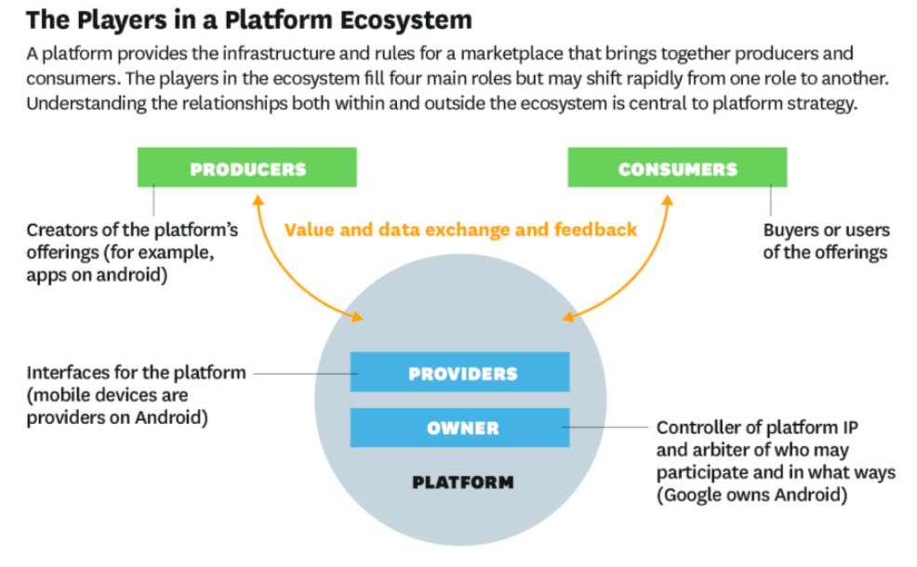

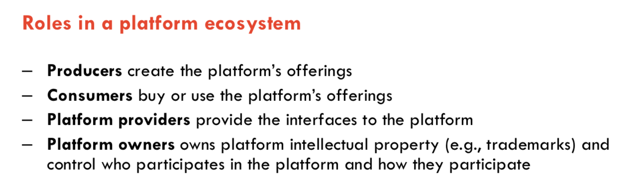

factory VS Facebook

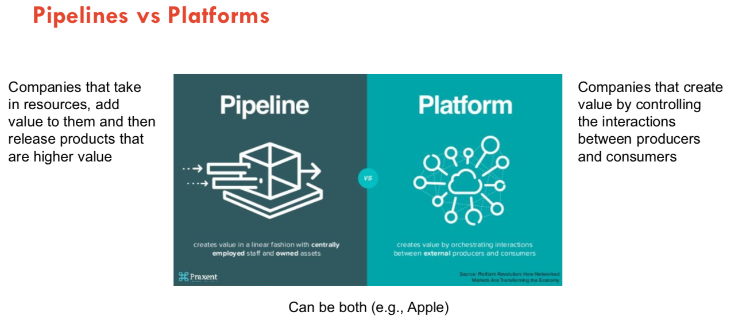

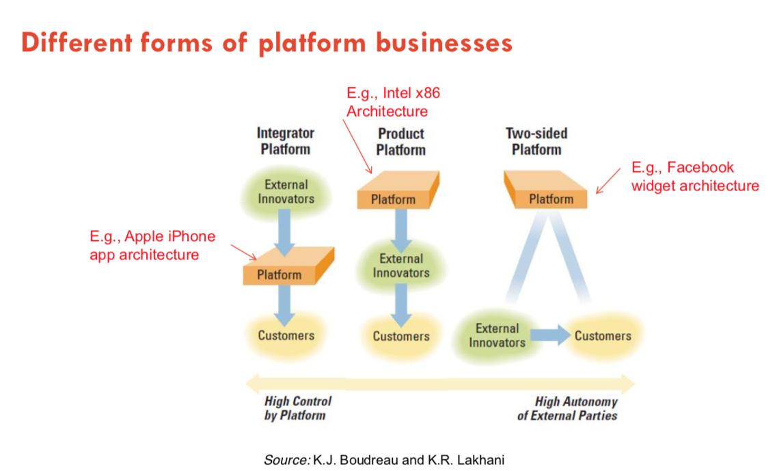

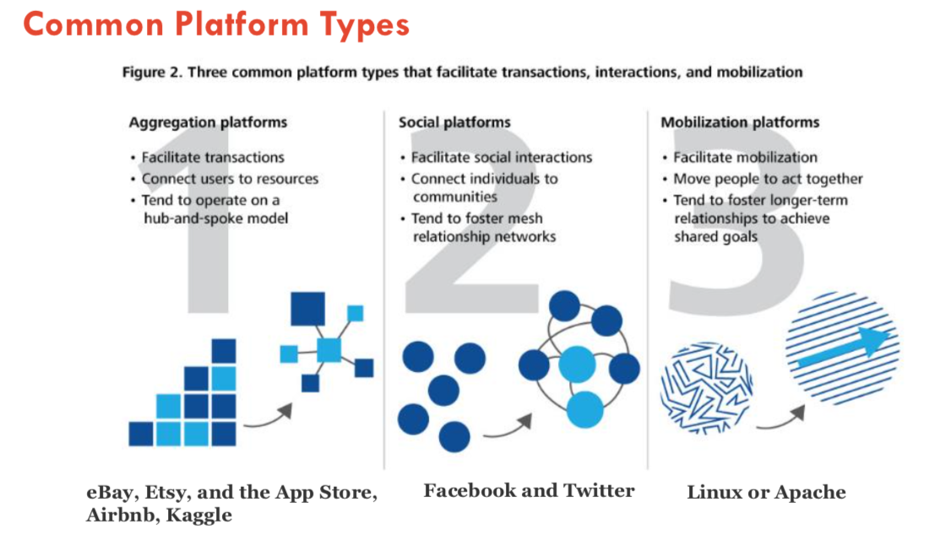

**Tutorial: Sharing Economy**

What are the IT technologies that are enabling sharing economy platforms?

The main technologies used are: Web APIs, Internet, Cloud Computing.

Key enabling technologies for sharing economy:

1. **P2P transaction-** This is a way of transferring money from one person to another with the help of an intermediary
2. **Social networking technologies-** These include crowd sourcing and crowd funding and using a social network improves the quality of end result

**Technologies to adopt in future:**  
a. Data analytics for customer retention and better customer service – Share data b. Augmented Reality and Virtual Reality – More immersive experiences  
c. Blockchain – Decentralize the core systems  
d. IoT – embed sensors to monitor service/products in real time

**Week8**

**Innovation by Startup Companies**

Entrepreneur: “the owner of a business enterprise who attempts to make profits by risk and initiative”

startup definition:

a temporary organization in search of scalable, repeatable, profitable business model

Why so many more ‘unicorn’ companies now?

–  Compelling products that are easier than ever to adopt

how to get **startup ideas**?

The way to get startup ideas is not to try to think of startup ideas. It's to look for problems, preferable problems you have yourself.

**traditional approach for startup**

treat startup as small version of large company

most business need a business plan to start

business plan needed for investment

why it’s not suitable? uncertainties of future make the plan uneasy to change.

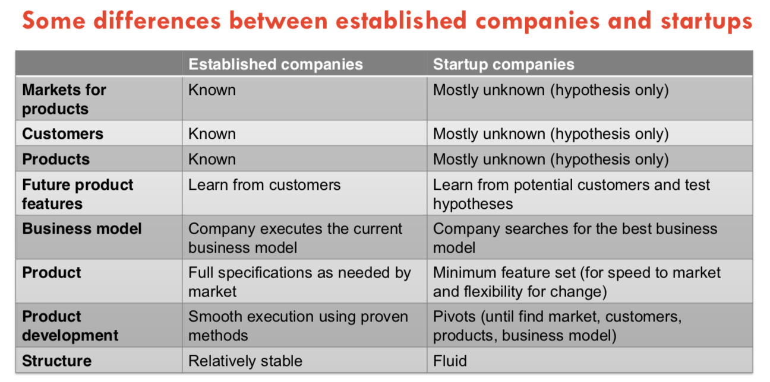

**New approach for startups (customer+ lean startup+3canvas)**

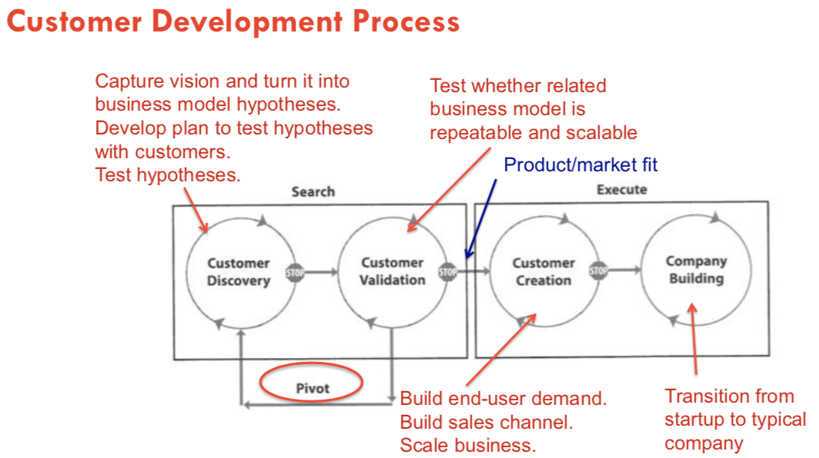

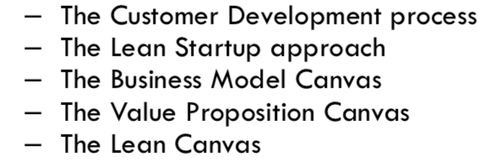

Lean(瘦的)

Proposition(主张)

**The startup – 3 key principles**

–  Customer Development: “get out of the building”

–  Business Model Canvas: “Sketch Out(简述) Your Hypotheses.”

–  Agile software development : “Quick, Responsive Development.”

**Tutorial 8 BMC**

The business Model canvas

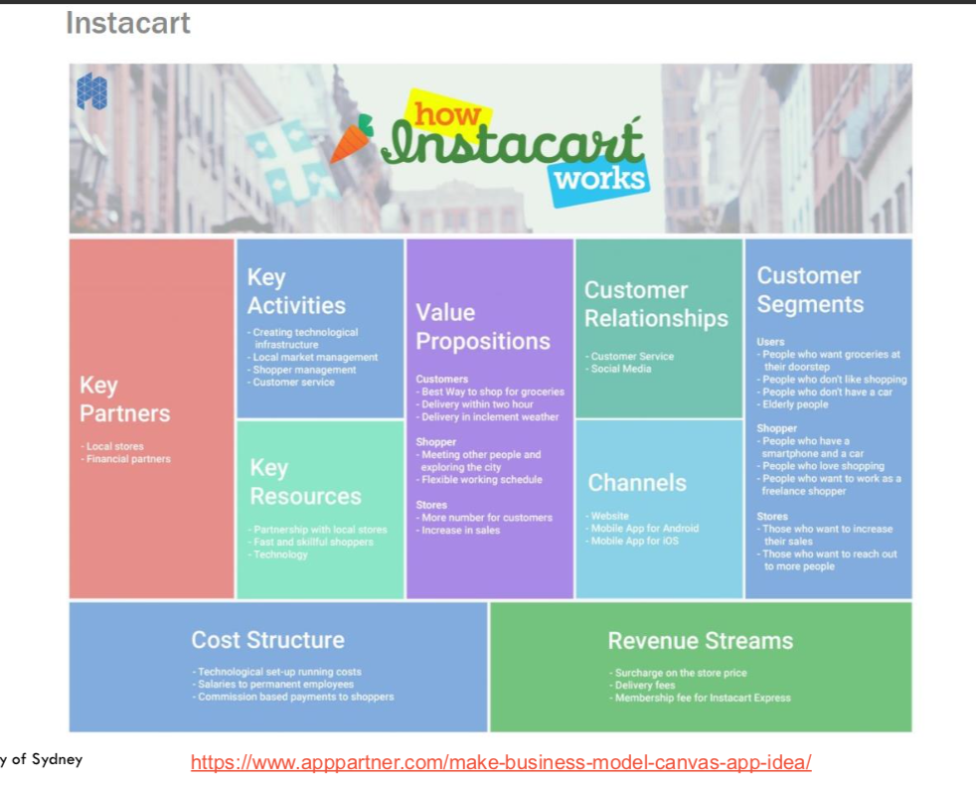

**Week 9. Innovation Management**

Problem with traditional approaches

– Impossible to know all requirements in advance  
– The project takes time, so the requirements at the time of capture may be different from those at the time of delivery  
– Some requirements are only clear when users are using the product

– Too long to get customer validation of product

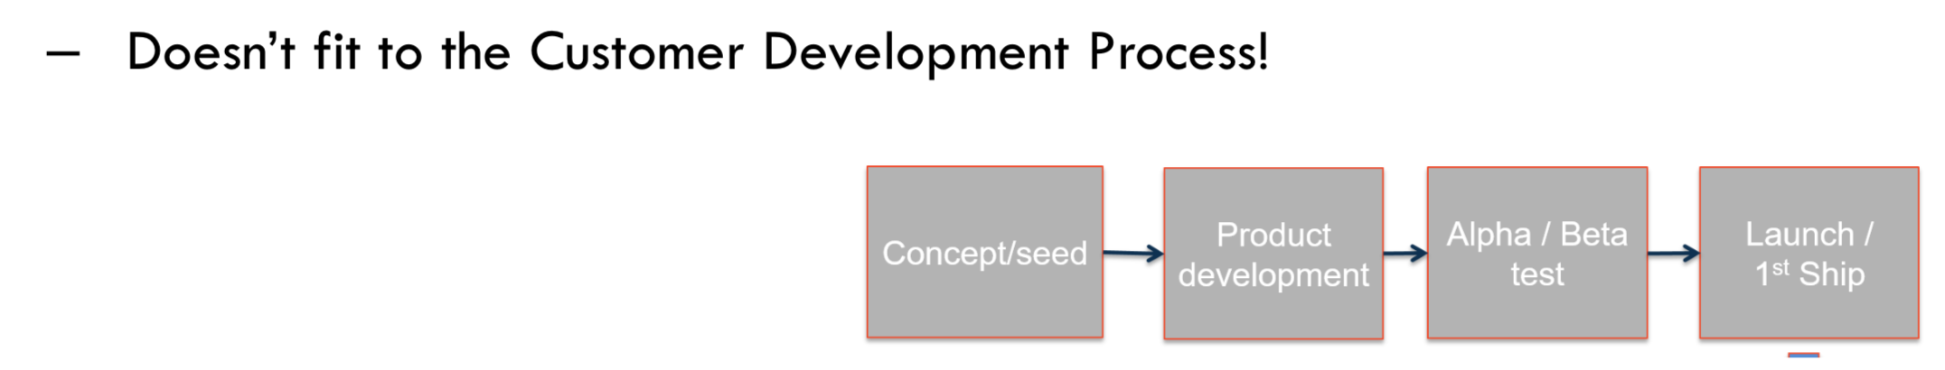

**“The Agile Manifesto” (2001)**

Through this work we have come to value: (goals )

**Individuals and interactions** over(高于) processes and tools

**Working software** over comprehensive documentation

**Customer collaboration** over contract negotiation

**Respond to change** over follow a plan

Principles behind the Agile Manifesto(12 items)

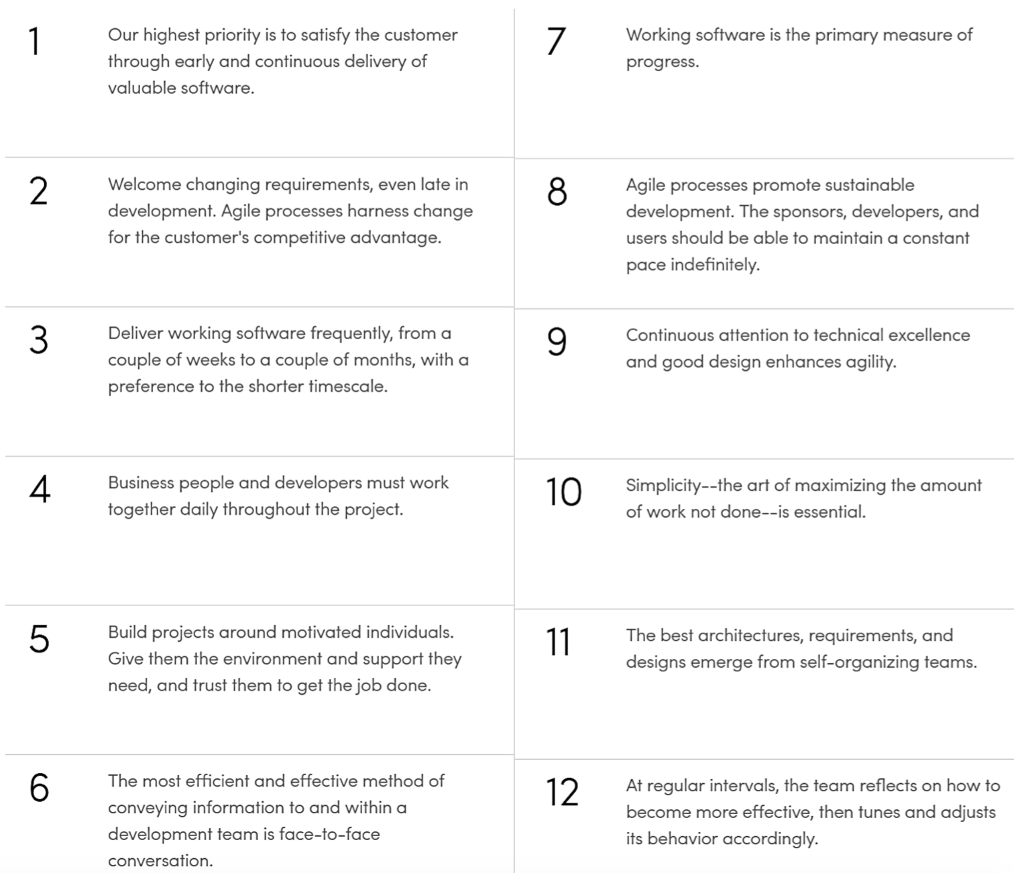

**Agile Alliance** - Key Agile Concepts :

–  User Stories

–  Daily Meeting

–  Incremental Development

–  Iterative Development

–  Team: A "team" in the Agile sense is a small group of people

–  Milestone Retrospective

–  Persons

Why traditional product processes are not suitable for startups ?

Innovation happen in a very uncertain environment with many uncertainties, so agile is better because it could deal uncertainty well compared with waterfall approach

1. using agile approach has higher customer satisfaction
2. using agile approach could be more flexible which means it could incorporate new requirements at any point of the process
3. accelerate the innovation diffusion because it delivers products to market quicker

**New approaches for startups:**

– The Customer Development process

– The Lean Startup approach  
– The Business Model Canvas  
– The Value Proposition Canvas

– The Lean Canvas

**Lean startup** doesn’t suit everything?

–  Big visions for short-term monopoly

–  (Peter Thiel)

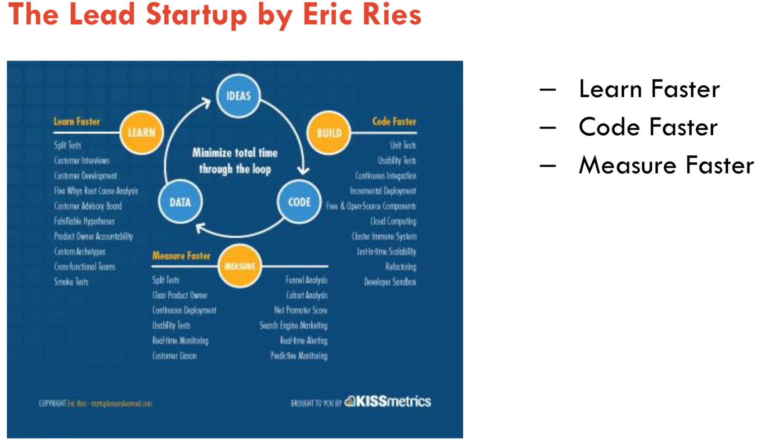

The Minimum Viable Product (MVP)

Definition (from Eric Reis):  
“the minimum viable product is that version of a new product which allows a team to collect the maximum amount of validated learning about customers with the least effort.”

1. **Entrepreneurs are everywhere** - You don't have to work in a garage to be in a startup.
2. **Entrepreneurship is management** - A startup is an institution, not just a product, so it requires management, a new kind of management specifically geared to its context.
3. **Validated learning** - Startups exist not to make stuff, make money, or serve customers. They exist to learn how to build a sustainable business.
4. **Innovation accounting** - To improve entrepreneurial outcomes, and to hold entrepreneurs accountable, we need to focus on the boring stuff: how to measure progress, how to setup milestones, how to prioritize work. This requires a new kind of accounting, specific to startups.
5. **Build-measure-learn** - The fundamental activity of a startup is to turn ideas into products, measure how customers respond, and then learn whether to pivot or persevere.

Week10, week 11